Smart Classroom
In the Mechanical Engineering department, smart classroom boards with interactive capabilities have become a crucial tool for enhancing teaching and learning. These smart boards allow instructors to present complex concepts, such as thermodynamics, fluid mechanics, machine design, and manufacturing processes, in a highly visual and interactive manner. The ability to display 3D models, simulations, and animated diagrams enables students to better understand intricate mechanisms, gear assemblies, stress-strain behaviors, and heat transfer processes that are often difficult to grasp through traditional teaching methods.
Videos, CAD simulations, and interactive presentations are extensively utilized in smart classes, making lectures more engaging and fostering active learning. For example, a simulation of a CNC machine operation or a fluid flow in a pipe system can visually demonstrate real-world applications, bridging the gap between theory and practice. Students are more receptive to this type of instruction as it stimulates both visual and auditory senses, enhancing retention and comprehension of engineering principles.
Moreover, smart boards allow instructors to annotate diagrams in real-time, manipulate digital prototypes, and conduct interactive problem-solving sessions, which helps students develop a practical understanding of concepts. This multimodal approach not only improves conceptual clarity but also encourages analytical thinking and problem-solving skills, which are essential competencies for aspiring mechanical engineers.

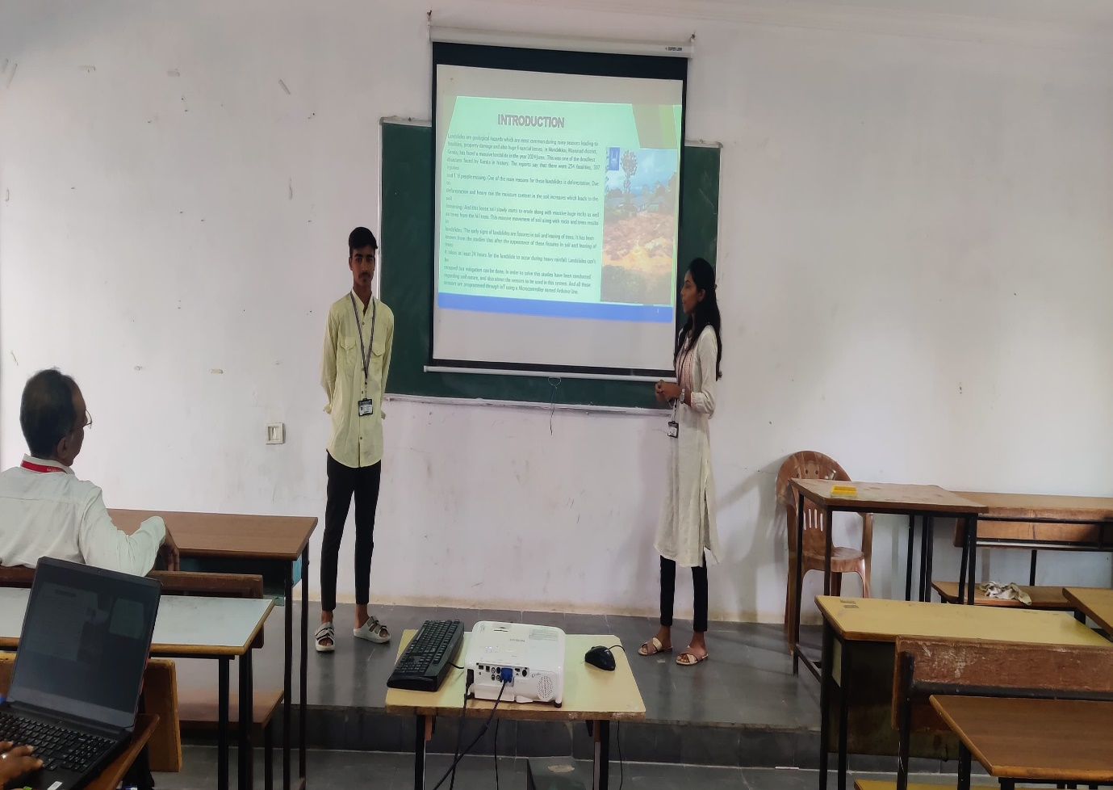

In summary, the integration of smart classroom technologies in the Mechanical Engineering curriculum transforms traditional lectures into dynamic learning experiences, making abstract concepts tangible, improving student engagement, and fostering a deeper understanding of complex engineering phenomena.

Innovative activities undertaken by faculty members to improve teaching and learning process:
- The faculty are oriented towards outcome based Education (OBE) and are actively utilizing the OBE to cater the learning needs of students by innovative way.
- Faculty Innovations in Teaching is being supported and followed at the institutional level, to improve teaching and learning process. Faculty members are encouraged for certification courses to enhance their competencies. Pedagogical approaches include PPTs, online classrooms, blogs, models, charts etc., along with conventional methodologies.
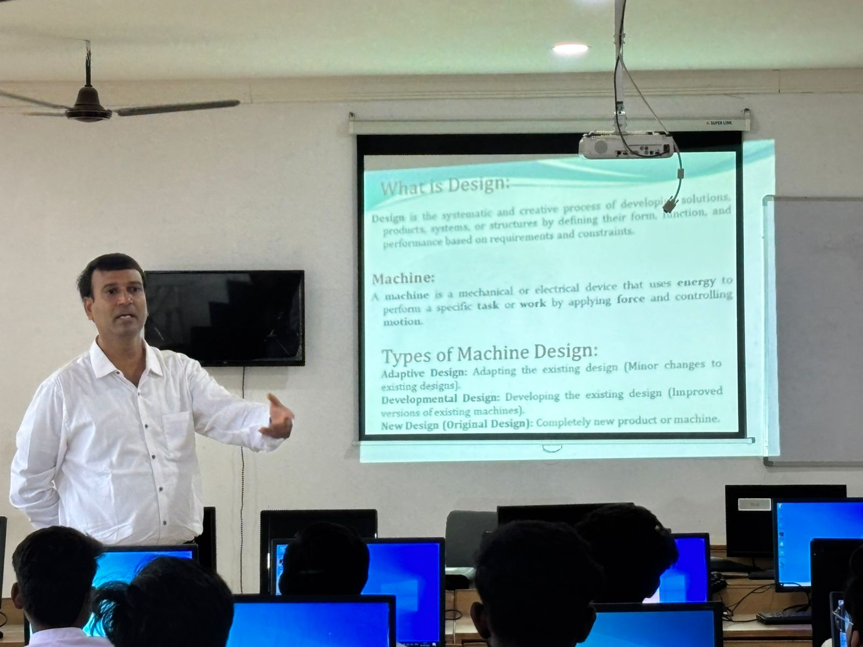
Innovations in Teaching and Learning: Faculty Online Instruction Using PowerPoint

